Details for podcast

Music: “Quia felix puericia – Magnificat” by Hildegard of Bingen

Performed by Sequentia, Barbara Thornton & Benjamin Bagby from the album Hildegard von Bingen: O Jerusalem (1985) © 1995, 1997 Sony Music
For further reflection:

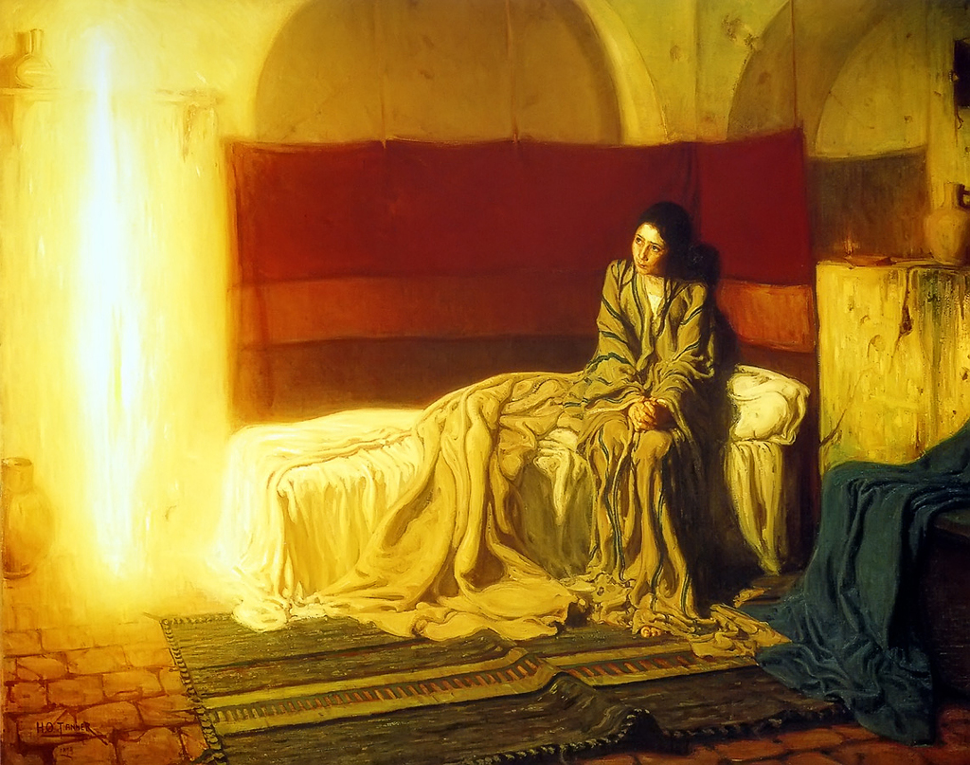
The Annunciation by Henry Ossawa Tanner (1898)

The season of Advent is framed and punctuated by Angels. An angel announces to Zechariah that he and Elizabeth are to have a baby who will prepare the way for the coming Messiah. An angel speaks in a dream to Joseph reassuring him that the child Mary has conceived is of the Holy Spirit. The angel, Gabriel, delivers God’s world altering commission to Mary. And a full host of angels join the angelic messenger declaring the good news of Christ’s birth to the shepherds. In each of these remarkable encounters, the words of the angels are the same: “Do not be afraid.”

The angelic message may have been the same, but the human responses varied, at least in one case. Poor Zechariah, perhaps it was just too much for him to take in! His response is one of fear and disbelief. He’s terrified by the angel, he doubts, is struck dumb for his faithlessness and has to wait until his son, John the Baptist, is born before he regains his speech.

Zechariah’s response is a stark contrast to the other three (Mary, Joseph and the Shepherds) who listen, receive and respond with affirmation, courage and faith. Mary’s “yes” is most significant because it is she who carries within her the child who is the hope of the world, the physical incarnation of God and God’s plan of salvation. Hers is the final candle in the outer ring of our Advent wreath. This is symbolic of her role in completing the circle of God’s divine plan.

Visual representations of The Annunciation are too numerous to count! I am particularly drawn to those Renaissance images of Mary reading a book being and being visited by a winged messenger or bird. However, I recently became aware of an utterly striking depiction of The Annunciation painted by Henry Ossawa Tanner in 1898.

Tanner was an African-American artist who aligned himself with the modern Realists in Paris. He was also man of faith, the son of a Methodist Episcopal bishop, who often chose to paint religious themes. As such, he was challenged by his Realist fellows as to how he might ‘realistically’ render an angel.

Tanner made innovative use of a column of light to represent the angel Gabriel, and the result is dazzling. The light that is Gabriel pervades the entire room and becomes the sole light source in the painting. Gabriel illuminates Mary in his Heavenly glow. Mary is of course the other dazzling presence in the painting. Tanner renders her remarkably in her ordinariness and humanity. There is a seriousness about her which we can ‘read’ in her posture - her slightly raised shoulders and her clasped hands. Yet, in her beautiful face there is calm and there is acceptance. Her gaze is lost, unflinchingly, in the magnificent pillar of light. She is not afraid.

The pillar of light reminds me of the Lord going before the Israelites as they left Egypt — guided by a pillar of cloud by day and a pillar of fire by night, as we read in Exodus 13:21. The Lord would always be before Mary as the light of her life; but there would dark days as well, as the painting itself suggests ever so subtly – the pillar of light forms the image of a cross in the background.

Mary’s “Yes” was not without cost. Not without trial and tribulation, sadness and grief. But still, she allowed herself to say yes, and she continued to say yes for the rest of her life. What joy, to find her once again collaborating with the Holy Spirit, in the book of Acts. When the Holy Spirit comes with tongues of fire at Pentecost, Mary is there, ready to bear Jesus once again, this time, out into the wider world proclaiming his story, and hers.

The Annunciation is, of course, a particular encounter, unique to and for Mary: only she can do the task that is set before her, only she can be the Mother of Jesus. However, this very specific encounter underscores for us the continuing work of the Holy Spirit in our own lives.

The Holy Spirit is always engendering new life, inviting each of us to collaborate with God in ways that will release us to be most truly ourselves, who were we made to be, to fulfil the purpose for which we were formed.

Are there times when we, like Zechariah, are afraid what God may be asking us to do or be? Can we sometime be fearful that letting God further into our lives may make us less ourselves?

The story of Mary shows us that we need not be afraid, for the Lord who calls us into service will go before us, by day and by night, be with us on the journey, and empower us with all that we need to meet the challenge and heed His call.

Do not be afraid!

Amen.

