Music note for Day 8:

“In Evangelium (Antifona)” by Hildegard von Bingen, from the album – Hildegard Von Bingen: Carmina canti spirituali” © 1996 EDM

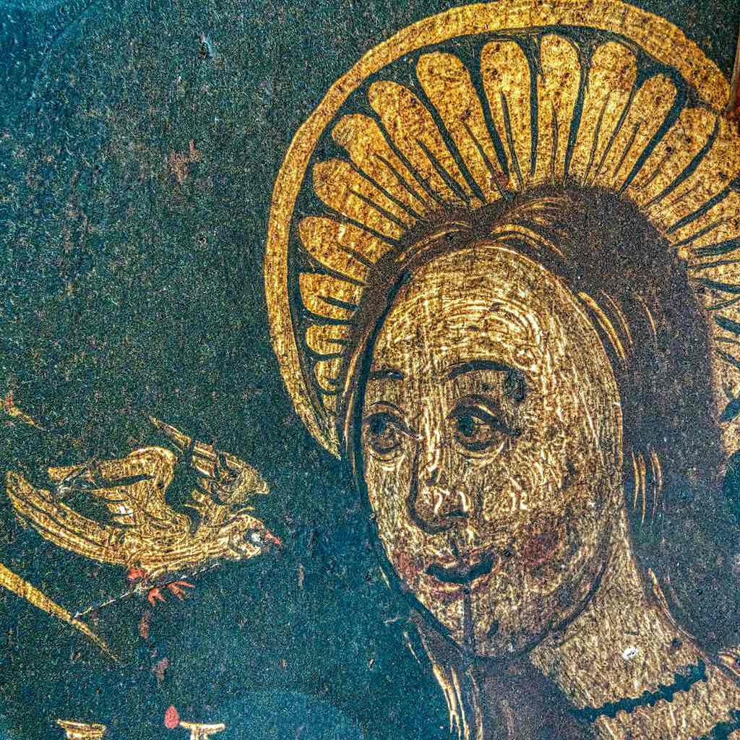

Dare to declare who you are.
It is not far from the shores of silence to the boundaries of speech. The path is not long, but the way is deep. You must not only walk there, but you must also be prepared to leap.
The mystery of God hugs you in its all-encompassing arms.
– Hildegard of Bingen (1098-1179)
Prayer for Courage
Courage comes for the heart and we are always welcomed by God,
The Heart of all being.
We bear witness to our faith,\knowing that we are called
To live lives of courage, love and reconciliation
In the ordinary and extraordinary moments of each day.
We bear witness, too, to our failures and our complicity in the fractures of our world.
May we be courageous today.
May we learn today.
May we love today.
Amen.

O Tuama, Padraig. Daily Prayer with the Corrymeela Community, 2017.

