Further Thoughts & Music Notes for Day 24

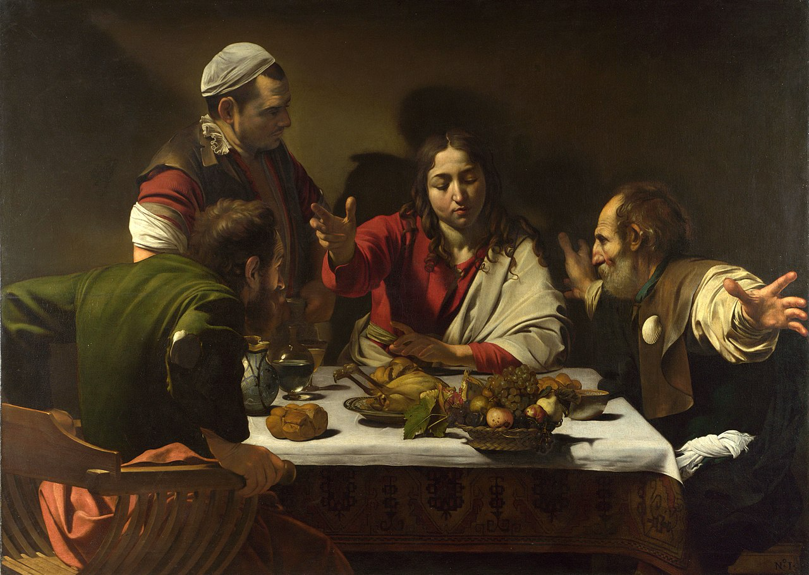
Supper at Emmaus by Caravaggio (1601)

Music note for Day 24:

“Tomorrow shall be my dancing day”, performed by Simon Preston, The Choir Of Westminster Abbey & Christopher Herrick from the album – Choir of Westminster Abbey – Christmas Carols This Compilation © 1984 Deutsche Grammaphon GmbH, Berlin

